STARTING QUESTIONS

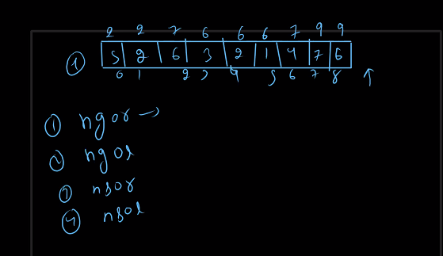

Remove outer most brackets

HELLO KAALI

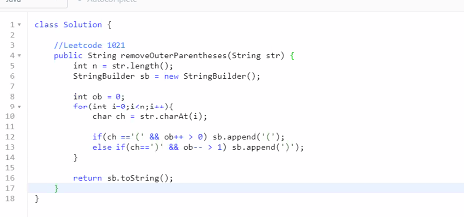

**LEETCODE 1249**

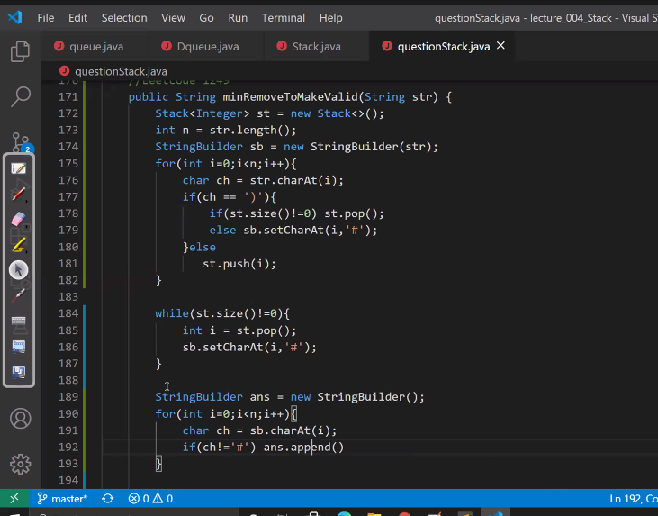

**Jis bhi character ko string mei se remove karna hai usko setCharAt ki help se pehle mark karo fir traversal karte vakh answer banao yahi best tareeka hai if you try direct deletion then you will face high time complexity**

**Leetcode 735**

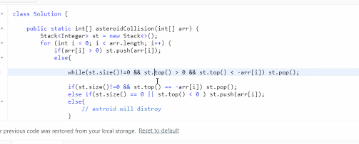

**Max rectangle**

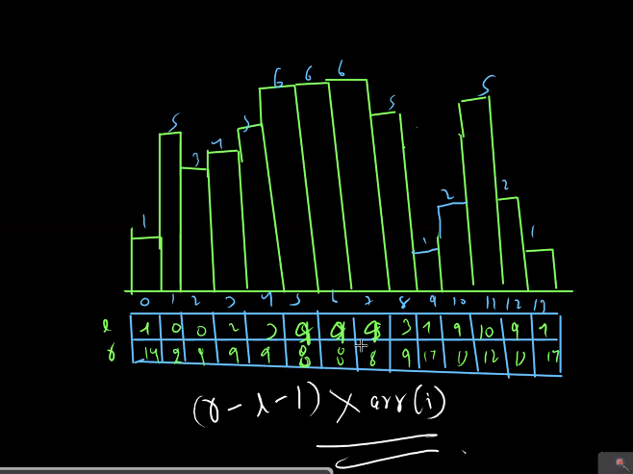

**TRAPPING RAIN WATER LEETCODE**

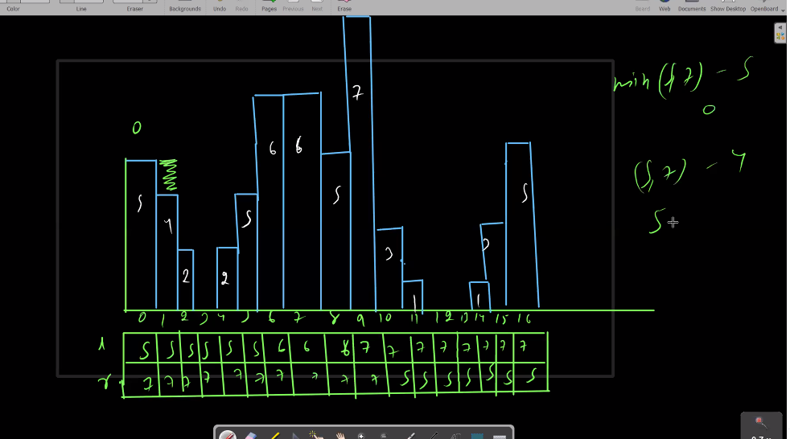

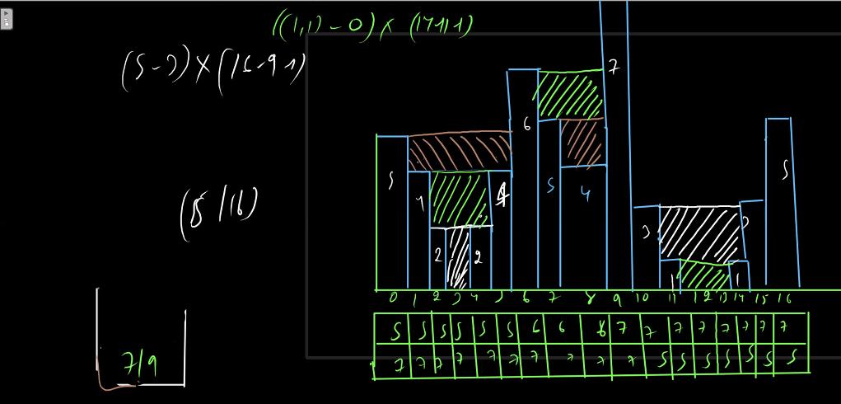

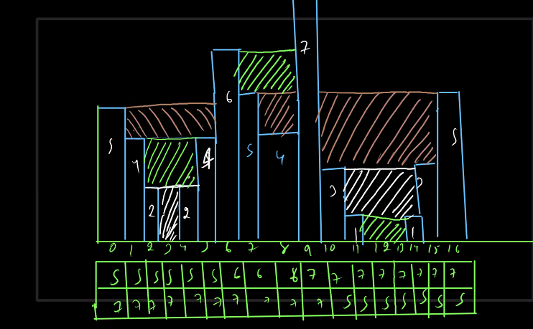

**Optimized approach code –**

